|  |
| --- |
| Artificial ORDER |
| Cop-Thief Shooter |
| **[A Bullet-hell shooter game]** |
| Version #03  All work Copyright © 2019 Artificial Order.  All rights reserved. |
| **[Rohan Juneja]** |
|  |

|  |
| --- |
| Oct 05th 2019 |

**Table of Contents**

Table of Contents

Game Overview4

Game Play Mechanics**4**

Camera**4**

Controls **5**

Saving and Loading **5**

Interface Sketch **5**

Game World **5**

Characters **7**

Enemies **8**

Scoring **9**

Sound Index **9**

Art/Multimedia Index **10**

**Version History**

Version 01

Added Game Overview, Mechanics and other details.

Added Player and enemy

Version 02

Modified Game Overview

Added Sound Index

Added Art/Multimedia Index

Added Interface Sketch

Version 03

Modified Game Mechanics, Added Mouse Click to shoot

Added Graphics to show mechanics

Completed the game design document

[This is the body of your video game design document. You should add and delete sections as they pertain to your game’s design.]

1. **Game Overview**

*The game features a cop trying to kill thieves by shooting lasers at the thieves. The game revolves around the scene of how easy it is getting nowadays to kill/arrest thieves/murderers all around the city. Killing each thief gives 100 scores.*

1. **Game Play Mechanics**

*This game is played using WASD Controls for movement*

*Use Left Ctrl / Left Mouse Click to shoot.*

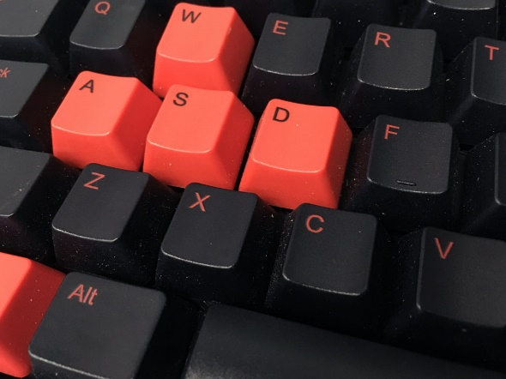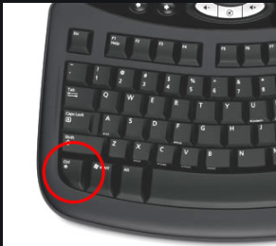 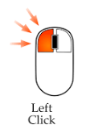

1. **Camera**

*It’s a 2D Game, there is a scrolling background, but the camera remains still.*

1. **Controls**

*The game uses keyboard and a mouse.  
Keyboard is used to move around the game environment.*

*Mouse is used to shoot.*

1. **Saving and Loading**

*No. The game doesn’t include saving and loading. It’s made for fun purpose.*

1. **Interface Sketch**

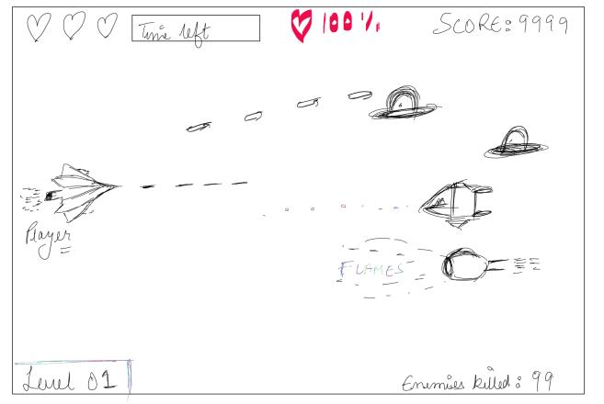

1. **Game World**

*The game feels like the player is flying across the mountain area finding thieves/enemies to kill.*

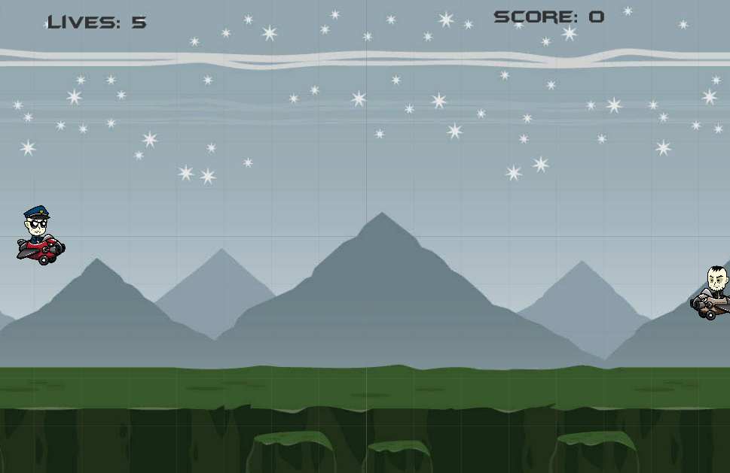

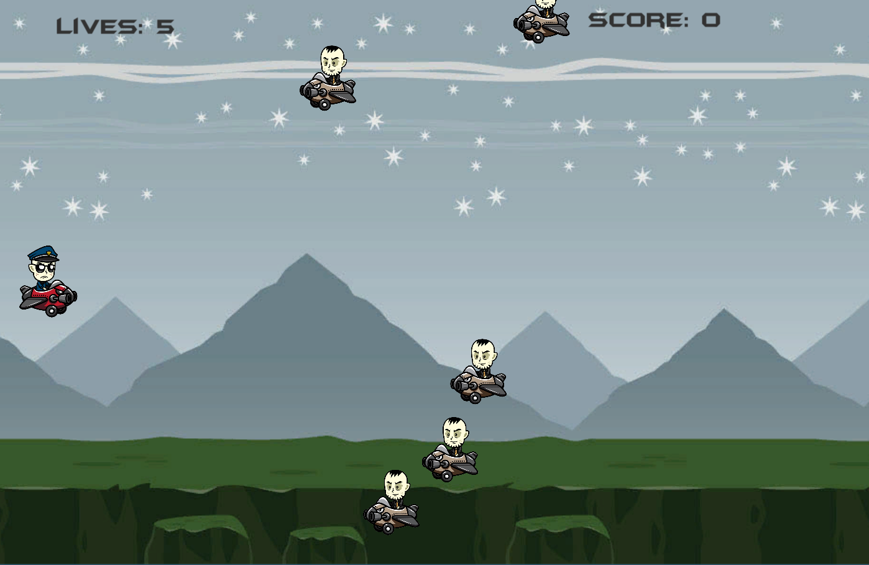

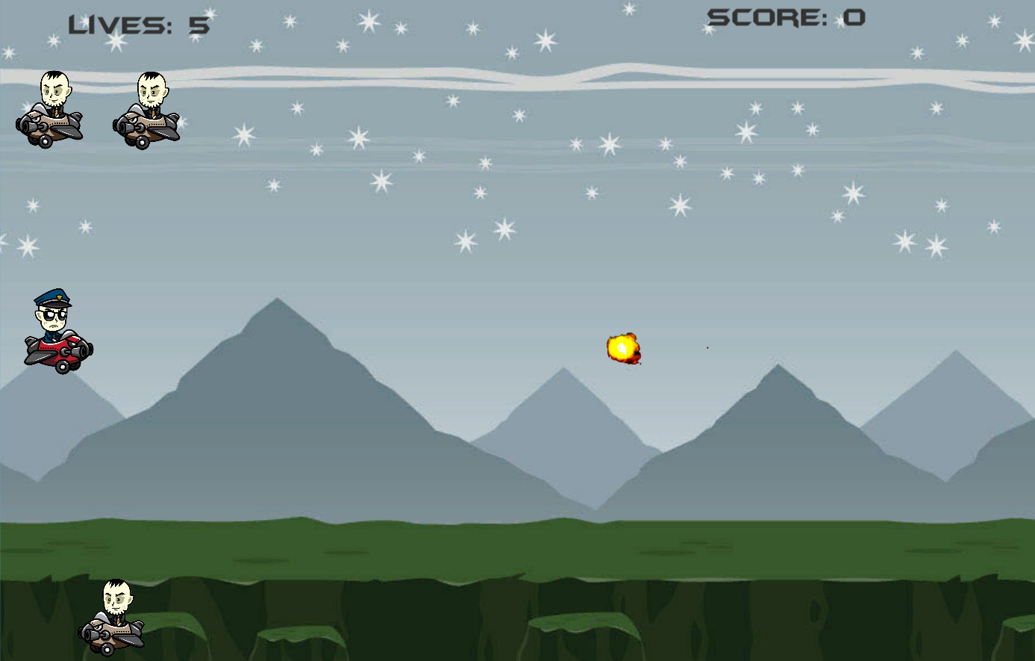

*The player shoots at the enemies.*

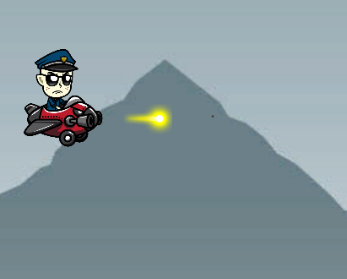

1. **Characters**

*The character looks like a cop in his flying vehicle that can shoot at enemies. The cop is designed in such a way that he looks more dangerous and cunning.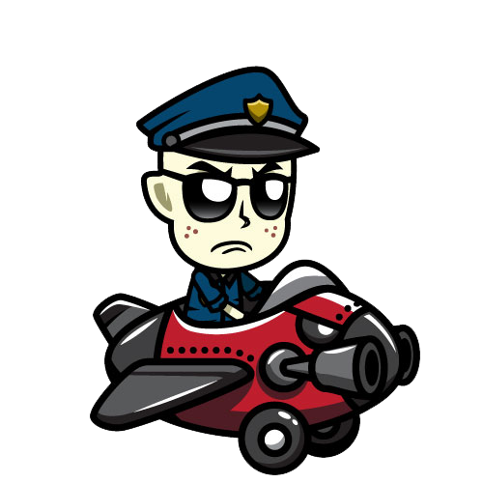*

1. **Enemies**

*The thief looks like a dangerous criminal in his flying car with no ability to shoot.*



1. **Scoring**

*There are total 5 lives and for killing each enemy there is a score mark of 100 points. The more you kill, the more scores you get.*



1. **Sound Index**
2. *Intro/Main Sound – this sound plays on the beginning of the game till the end.*
3. *Laser Sound – this sound is played when the player shoots.*
4. **Art / Multimedia Index**

*The background is a mountain area.*



This is the sprite for explosion.

